Carbon Cycles and Energy Flow through Ecosystems and the Biosphere

The biosphere includes all of the Earth’s organisms. Life in the biosphere depends on a continuous inflow of energy from the sun.

1a. Suggest a hypothesis to explain why life in the biosphere needs a continuous inflow of energy.

1b. Life in the biosphere requires carbon atoms. However, the
biosphere does not receive an inflow of carbon atoms. Suggest a hypothesis to explain how life in the biosphere continues without an inflow of carbon atoms.

To better understand why the biosphere needs an inflow of energy, but not carbon atoms, we will review three biological processes that transform energy and carbon-containing molecules.

Photosynthesis  Plant cells use the energy from sunlight to make sugar molecules from CO₂ and H₂O. | The upper box shows changes in how the atoms are organized in molecules. The lower box shows the associated energy changes.

2a. Circle the glucose molecule in the chemical equation for photosynthesis.

2b. Explain how photosynthesis illustrates the following general principle.
Atoms are neither created nor destroyed in biological processes.

2c. Explain how photosynthesis illustrates the following general principles.
Energy is neither created nor destroyed in biological processes, but energy can be transformed from one type to another. During energy transfers and transformations, some of the input energy is transformed to heat energy.

Cellular Respiration  These equations summarize how cellular respiration produces ATP.  3a. Why do cells need ATP? | The curved arrows represent coupled chemical reactions; the  top reaction provides the energy needed for the second reaction.

3b. Why is glucose needed for cellular respiration to produce ATP?

3c. What process produces the glucose that plant cells use for cellular respiration?
Biosynthesis
Some of the sugar molecules produced by photosynthesis are used for biosynthesis, which produces all the different organic molecules that make up an organism. For example, multiple
glucose molecules are combined to make the polymer cellulose, which is used to make plant cell walls. Animals and decomposers use digested food molecules as inputs for biosynthesis.

These biological processes result in the carbon cycle, where carbon atoms cycle between CO₂ in the air and organic molecules in living organisms and dead organic matter. The figure below shows a carbon cycle that includes a simple food web.

4a. The B arrow shows CO₂ entering a plant. How do the carbon atoms in CO₂ become carbon atoms in organic molecules in the plant? | 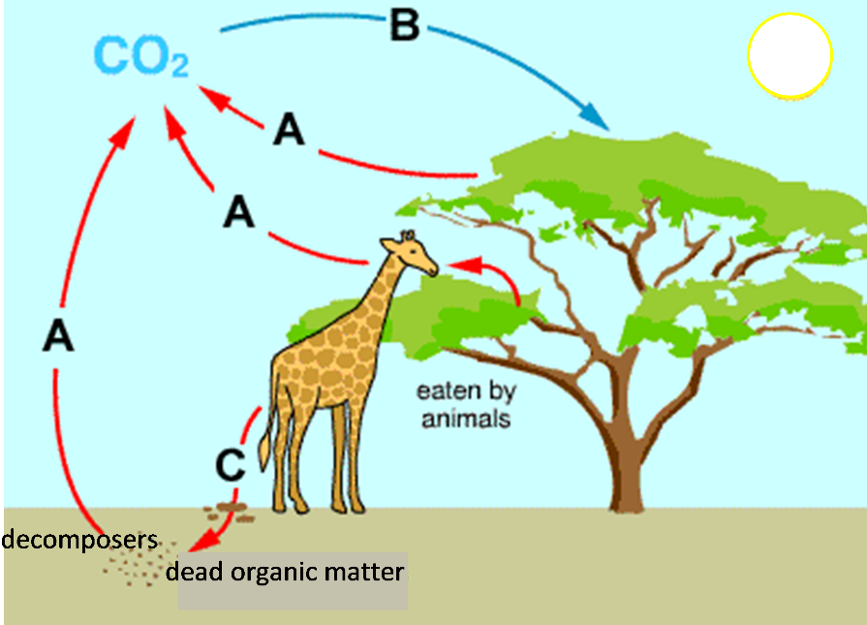

4b. The A arrows show CO₂ leaving plants, animals and decomposers. How do the carbon atoms in the organic molecules of plants, animals and decomposers become carbon atoms in CO₂?

4c. The C arrow shows defecation and/or death. Add another C arrow to show part or all of the tree dying and becoming available to decomposers.

5a. Carbon atoms in organic molecules in a tree can become carbon atoms in organic molecules in a giraffe. Fill in the blanks to describe how this can happen.

The giraffe __________________________________________________________ .
The giraffe’s digestive and circulatory systems _______________________________________.
The giraffe’s cells _______________________________________________________________.
5b. Explain how a carbon atom in an organic molecule in a giraffe could become a carbon atom in an organic molecule in a tree. (Hint: A complete answer will include cellular respiration, photosynthesis, and biosynthesis.)

In this figure, energy flows (represented by dashed arrows) have been added to the carbon
cycle.

6a. This figure does not show the energy transformations and transfers inside the living organisms. For example, photosynthesis
transforms light energy to chemical energy, and cellular respiration transfers chemical energy between molecules. All of these processes

produce _________, which is radiated away from the ecosystem.

6b. Label each dashed arrow in the above figure with one of these abbreviations:
S = the inflow of energy in the form of sunlight.
CE = chemical energy moving from one trophic level to the next in the food web or moving from a living organism to dead organic matter.
H = for arrows that show that biological processes produce heat, which leaves the organisms and ultimately is radiated out to space.

7. How can the sun’s energy be transformed to provide the energy that a giraffe uses to move? Be specific about the multiple steps that are required.

8a. Explain why life in the earth’s biosphere needs a continuous inflow of energy.

8b. How can life in the earth’s biosphere continue without an inflow of additional carbon atoms?

By Dr. Ingrid Waldron, Dept Biology, University of Pennsylvania. © 2021. This Student Handout and the Teacher Preparation Notes with instructional suggestions and background information are available at https://serendipstudio.org/exchange/bioactivities/carboncycle.

